ECOSYTEM
Concept of an Ecosystem:
Living organisms cannot live isolated from their non-living environment because the latter provides materials and energy for the survival of the former i.e. there is interaction between a biotic community and its environment to produce a stable system; a natural self-sufficient unit which is known as an ecosystem.Ecosystem are the parts of nature where living orgaisms interact among themselves and with their physical environment.
The term ‘ecosystem’ was coined by A.G. Tansley, an English botanist, in 1935. An ecosystem is the structural and functional unit of ecology (nature) encompassing complex interaction between its biotic (living) and abiotic (non-living) components.For example- a pond is a good example of ecosystem. A pond, lake, desert, grassland, meadow, forest etc. are common examples of ecosystems.

Structure and Function of an Ecosystem:

Each ecosystem has two main components:
- Abiotic

- Biotic

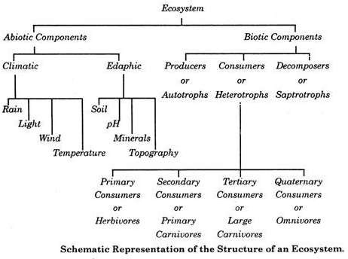

- Abiotic components (Nonliving): The abiotic component can be grouped into following categories:-
  - Climatic Factors: Which include rain, temperature, light, wind, humidity etc.
  - Edaphic Factors: Which include soil, pH, topography minerals etc.

The functions of important factors in abiotic components are given below:
Soils are much more complex than simple sediments. They contain a mixture of weathered rock fragments, highly altered soil mineral particles, organic matter, and living organisms. Soils provide nutrients, water, a home, and a structural growing medium for organisms. The vegetation found growing on top of a soil is closely linked to this component of an ecosystem through nutrient cycling.
The atmosphere provides organisms found within ecosystems with carbon di•oxide for photosynthesis and oxygen for respiration. The processes of evapora•tion, transpiration and precipitation cycle water between the atmosphere and the Earth’s surface.
Solar radiation is used in ecosystems to heat the atmosphere and to evapo•rate and transpire water into the atmosphere. Sunlight is also necessary for photosynthesis. Photosynthesis provides the energy for plant growth and metabolism, and the organic food for other forms of life.
Most living tissue is composed of a very high percentage of water, up to and even exceeding 90%. The protoplasm of a very few cells can survive if their water content drops below 10%, and most are killed if it is less than 30-50%.
Water is the medium by which mineral nutrients enter and are trans-located in plants. It is also necessary for the maintenance of leaf turgidity and is required for photosynthetic chemical reactions. Plants and animals receive their water from the Earth’s surface and soil. The original source of this water is precipitation from the atmosphere.
- Biotic components:The living organisms including plants, animals and micro-organisms (Bacteria and Fungi) that are present in an ecosystem form the biotic components.

Producers:
The green plants have chlorophyll with the help of which they trap solar energy and change it into chemical energy of carbohydrates using simple inorganic compounds namely water and carbon dioxide. This process is known as photosynthesis. As the green plants manufacture their own food they are known as Autotrophs (i.e. auto = self, trophos = feeder)
The chemical energy stored by the producers is utilised partly by the producers for their own growth and survival and the remaining is stored in the plant parts for their future use.

Consumers:
The animals lack chlorophyll and are unable to synthesise their own food. Therefore, they depend on the producers for their food. They are known as heterotrophs (i.e. heteros = other, trophos = feeder)

The consumers are of four types, namely:

Primary Consumers or First Order Consumers or Herbivores:
These are the animals which feed on plants or the producers. They are called her•bivores. Examples are rabbit, deer, goat, cattle etc.

Secondary Consumers or Second Order Consumers or Primary Carnivores:
The animals which feed on the herbivores are called the pri•mary carnivores. Examples are cats, foxes, snakes etc.

Tertiary Consumers or Third Order Consumers:
These are the large carnivores which feed on the secondary consumers. Example are Wolves.

Quaternary Consumers or Fourth Order Consumers or Omnivores:
These are the largest carnivores which feed on the tertiary consumers and are not eaten up by any other animal. Examples are lions and tigers.

Decomposers or Reducers:
Bacteria and fungi belong to this category. They breakdown the dead organic materials of producers (plants) and consumers (animals) for their food and re•lease to the environment the simple inorganic and organic substances produced as by-products of their metabolisms.
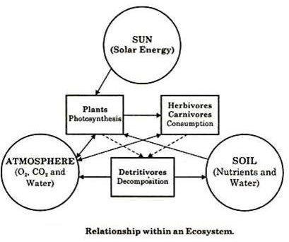These simple substances are reused by the producers resulting in a cyclic exchange of materials between the biotic community and the abiotic environment of the ecosystem. The decomposers are known as Saprotrophs (i.e., sapros = rotten, trophos = feeder).

Functions of ecosystem
Ecosystems are complex dynamic system. They perform certain functions. These are: Functions of Ecosystem:
- Productivity,
- Decomposition,
- Physical (energy flow),
- Biological (food chains, food web, ecological succession),and
- Biogeochemical (nutrient cycling) processes

PRODUCTIVITY
A constant input of solar energy is the basic requirement for any ecosystem to function and sustain. Primary production is defined as the amount of biomass or organic matter produced per unit area over a time period by plants during photosynthesis. It is expressed in terms of weight (g –2 ) or energy (kcal m–2 ). The rate of biomass production is called productivity. It is expressed in terms of g –2 yr –1 or (kcal m–2 )yr –1 to compare the productivity of different ecosystems. It can be divided into gross primary productivity (GPP) and net primary productivity (NPP). Gross primary productivity of an ecosystem is the rate of production of organic matter during photosynthesis. A considerable amount of GPP is utilised by plants in respiration. Gross primary productivity minus respiration losses (R), is the net primary productivity (NPP). GPP – R = NPP Net primary productivity is the available biomass for the consumption to heterotrophs (herbiviores and decomposers). Secondary productivity is defined as the rate of formation of new organic matter by consumers. Primary productivity depends on the plant species inhabiting a particular area. It also depends on a variety of environmental factors, availability of nutrients and photosynthetic capacity of plants. Therefore, it varies in different types of ecosystems. The annual net primary productivity of the whole biosphere is approximately 170 billion tons (dry weight) of organic matter. Of this, despite occupying about 70 per cent of the surface, the productivity of the oceans are only 55 billion tons. Rest of course, is on land.

DECOMPOSITION
You may have heard of the earthworm being referred to as the farmer’s ‘friend’. This is so because they help in the breakdown of complex organic matter as well as in loosening of the soil. Similarly, decomposers break down complex organic matter into inorganic substances like carbon dioxide, water and nutrients and the process is called decomposition. Dead plant remains such as leaves, bark, flowers and dead remain of animals, including fecal matter, constitute detritus, which is the raw material for decomposition. The important steps in the process of decomposition are fragmentation, leaching, catabolism, humification and mineralisation.
Detritivores (e.g., earthworm) break down detritus into smaller particles. This process is called fragmentation.

By the process of leaching,watersoluble inorganic nutrients go down into the soil horizon and get precipitated as unavailable salts.
Bacterial and fungal enzymes degrade detritus into simpler inorganic substances. This process is called as catabolism. It is important to note that all the above steps in decomposition operate simultaneously on the detritus.
Humification and mineralisation occur during decomposition in the soil. Humification leads to accumulation of a dark coloured amorphous substance called humus that is highly resistant to microbial action and undergoes decomposition at an extremely slow rate. Being colloidal in nature it serves as a reservoir of nutrients.
The humus is further degraded by some microbes and release of inorganic nutrients occur by the process known as mineralisation.
Decomposition is largely an oxygen-requiring process. The rate of decomposition is controlled by chemical composition of detritus and climatic factors. In a particular climatic condition, decomposition rate is slower if detritus is rich in lignin and chitin, and quicker, if detritus is rich in nitrogen and water-soluble substances like sugars. Temperature and soil moisture are the most important climatic factors that regulate decomposition through their effects on the activities of soil microbes. Warm and moist environment favour decomposition whereas low temperature and anaerobiosis inhibit decomposition resulting in build up of organic materials.

ENERGY FLOW
The chemical energy of food is the main source of energy required by all living organisms. This energy is transmitted to different trophic levels along the food chain. This energy flow is based on two different laws of thermodynamics:
First law of thermodynamics, that states that energy can neither be created nor destroyed, it can only change from one form to another.Second law of thermodynamics, that states that as energy is transferred more and more of it is wasted.
The energy flow in the ecosystem is one of the major factors that support the survival of such a great number of organisms. For almost all organisms on earth, the primary source of energy is solar energy. It is amusing to find that we receive less than 50 per cent of the sun’s effective radiation on earth. When we say effective radiation, we mean the radiation which can be used by plants to carry out photosynthesis.
Most of the sun’s radiation that falls on the earth is usually reflected back into space by the earth’s atmosphere. This effective radiation is termed as the Photosynthetically Active Radiation (PAR).
Overall we receive about 40 to 50 percent of the energy having Photosynthetically Active Radiation and only around 2-10 percent of it is used by plants for the process of photosynthesis. Thus, this percent of PAR supports the entire world as plants are the producers in the ecosystem and all the other organisms are either directly or indirectly dependent on them for their survival.

The energy flow takes place via food chain and food web. During the process of energy flow in the ecosystem, plants being the producers absorb sunlight with the help of the chloroplasts and a part of it is transformed into chemical energy n in the process of photosynthesis.
This energy is stored in various organic products in the plants and passed on to the primary consumers in the food chain when the herbivores consume (primary consumers) the plants as food and convert chemical energy accumulated in plant products into kinetic energy, degradation of energy will occur through its conversion into heat.
Then followed by the secondary consumers. When these herbivores are consumed by carnivores of the first order (secondary consumers) further degradation will occur. Finally, when tertiary consumers consume the carnivores, again energy will be degraded. Thus, the energy flow is unidirectional in nature.
Based on the source of their nutrition or food, organisms occupy a specific place in the food chain that is known as their trophic level. Producers belong to the first trophic level, herbivores (primary consumer) to the second and carnivores (secondary consumer) to the third.(Fig.)
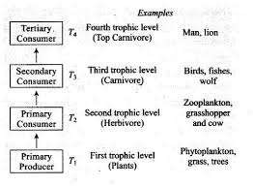

The important point to note is that the amount of energy decreases at successive trophic levels. When any organism dies it is converted to detritus or dead biomass that serves as an energy source for decomposers. Organisms at each trophic level depend on those at the lower trophic level for their energy demands. Each trophic level has a certain mass of living material at a particular time called as the standing crop. The standing crop is measured as the mass of living organisms (biomass) or the number in a unit area. The biomass of a species is expressed in terms of fresh or dry weight.
Moreover, in a food chain, the energy flow follows the 10 percent law. According to this law, only 10 percent of energy is transferred from one trophic level to the other; rest is lost into the atmosphere.

Iv . BIOLOGICAL
  - FoodChain
The transfer of food energy from the producers, through a series of organisms (herbivores to carnivores to decomposers) with repeated eating and being eaten, is known as food chain.
In nature, basically two types of food chains are recognized – grazing food chain and detritus food chain.
Food chains and energy flow are the functional properties of ecosystems which make them dynamic. The biotic and abiotic components of an ecosystem are linked through them.
There are two types of food chains:
- Grazing food chains: which starts from the green plants that make food for herbivores and herbivores in turn for the carnivores. Ecosystems with such type of food chain are directly dependent on an influx of solar radiation.
This type of chain thus depends on autotrophic energy capture and the movement of this captured energy to herbivores. Most of the ecosystems in nature follow this type of food chain.
A simple grazing food chain (GFC) is depicted below:

The phytoplanktons →zooplanktons →Fish sequence
or

the grasses →rabbit →Fox sequences are the examples, of grazing food chain.

- Detritus food chains: start from the dead organic matter to the detrivore organisms which in turn make food for protozoan to carnivores etc.
The detritus food chain (DFC) begins with dead organic matter. It is made up of decomposers which are heterotrophic organisms, mainly fungi and bacteria. They meet their energy and nutrient requirements by degrading dead organic matter or detritus. These are also known as saprotrophs (sapro: to decompose). Decomposers secrete digestive enzymes that breakdown dead and waste materials into simple, inorganic materials, which are subsequently absorbed by them.
In an aquatic ecosystem, GFC is the major conduit for energy flow. As against this, in a terrestrial ecosystem, a much larger fraction of energy flows through the detritus food chain than through the GFC. Detritus food chain may be connected with the grazing food chain at some levels: some of the organisms of DFC are prey to the GFC animals, and in a natural ecosystem, some animals like cockroaches, crows, etc., are omnivores.

Parasitic food chain
Parasitic food chain is also a auxiliary food chain. It begins with the host and usually end in parasite.

Food web
Simple food chains are very rare in nature because each organism may obtain food from more than one trophic level. Thus, in an ecosystem, the various food chains are interconnected to each other to form a network called food web. A food web illustrates all possible transfers of energy and nutrient among the organisms in an ecosystem, whereas food chain traces only one pathway of food. Food webs are very important in maintaining the stability of an ecosystem.

Differences between food chain and food web
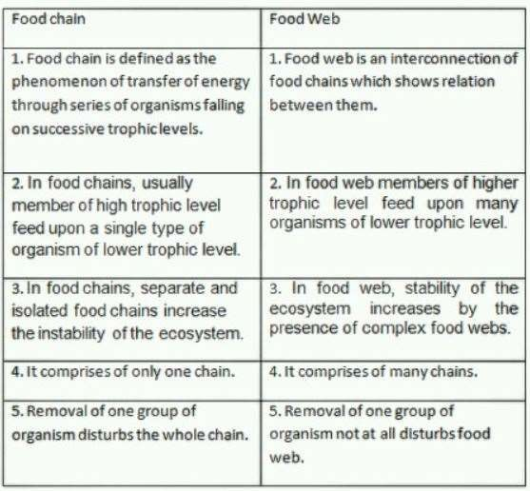

- ECOLOGICAL SUCCESSION
An important characteristic of all communities is that their composition and structure constantly change in response to the changing environmental conditions. This change is orderly and sequential, parallel with the changes in the physical environment. These changes lead finally to a community that is in near equilibrium with the environment and that is called a climax community. The gradual and fairly predictable change in the species composition of a given area is called ecological succession. During succession some species colonise an area and their populations become more numerous, whereas populations of other species decline and even disappear. The entire sequence of communities that successively change in a given area are called sere(s).
The individual transitional communities are termed seral stages or seral communities. In the successive seral stages, there is a change in the diversity of species of organisms, increase in the number of species and organisms as well as an increase in the total biomass. The present-day communities in the world have come to be because of succession that has occurred over millions of years since life started on earth. Actually, succession and evolution would have been parallel processes at that time. Succession is hence a process that starts where no living organisms are there – these could be areas where no living organisms ever existed, say bare rock; or in areas that somehow, lost all the living organisms that existed there. The former is called primary succession, while the latter is termed secondary succession.
primary succession
Primary succession is the series of community changes which occur on an entirely new habitat which has never been colonized before. For example, a newly quarried rock face or sand dunes. The establishment of a new biotic community is generally slow.
Secondary succession: Secondary succession begins in areas where natural biotic communities have been destroyed such as in abandoned farm lands, burned or cut forests, lands that have been flooded. Since some soil or sediment is present, succession is faster than primary succession.

Succession of Plants
Based on the nature of the habitat – whether it is water (or very wet areas) or it is on very dry areas – succession of plants is called hydrarch or xerarch, respectively. Hydrarch succession takes place in wetter areas and the successional series progress from hydric to the mesic conditions. As against this, xerarch succession takes place in dry areas and the series progress from xeric to mesic conditions. Hence, both hydrarch and xerarch successions lead to medium water conditions (mesic) – neither too dry (xeric) nor too wet (hydric). The species that invade a bare area are called pioneer species.
In primary succession on rocks these are usually lichens which are able to secrete acids to dissolve rock, helping in weathering and soil formation. These later pave way to some very small plants like bryophytes, which are able to take hold in the small amount of soil. They are, with time, succeeded by bigger plants, and after several more stages, ultimately a stable climax forest community is formed. The climax community remains stable as long as the environment remains unchanged.
In primary succession in water, the pioneers are the small phytoplanktons, they are replaced with time by rooted-submerged plants, rooted-floating angiosperms followed by free-floating plants, then reedswamp, marsh-meadow, scrub and finally the trees. The climax again would be a forest. With time the water body is converted into land (Figure 14.5).
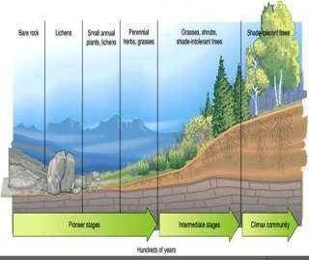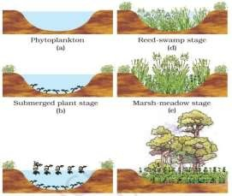

In secondary succession the species that invade depend on the condition of the soil, availability of water, the environment as also the seeds or other propagules present. Since soil is already there, the rate of succession is much faster and hence, climax is also reached more quickly. What is important to understand is that succession, particularly primary succession, is a very slow process, taking maybe thousands of years for the climax to be reached. Another important fact is to understand that all succession whether taking place in water or on land, proceeds to a similar climax community – the mesic.

V BIOGIOCHEMICAL PROCESSES NUTRIENT CYCLING
All elements in the earth are recycled time and again. The major elements such as oxygen, carbon, nitrogen, phosphorous, and sulphur are essential ingredients that make up organisms. Biogeochemical cycles refer to the flow of such chemical elements and compounds between organisms and the physical environment. Chemicals taken in by organisms are passed through the food chain and come back to the soil, air, and water through mechanisms such as respiration, excretion, and decomposition.As an element moves through this cycle, it often forms compounds with other elements as a result of metabolic processes in living tissues and of natural reactions in the atmosphere, hydrosphere, or lithosphere. Such cyclic exchange of material between the living organisms and their non-living environment is called Biogeochemical Cycle.
Nutrient cycles are of two types: (a) gaseous and (b) sedimentary. The reservoir for gaseous type of nutrient cycle (e.g., nitrogen, carbon cycle) exists in the atmosphere and for the sedimentary cycle (e.g., sulphur and phosphorus cycle), the reservoir is located in Earth’s crust. Environmental factors, e.g., soil, moisture, pH, temperature, etc., regulate the rate of release of nutrients into the atmosphere. The function of the reservoir is to meet with the deficit which occurs due to imbalance in the rate of influx and efflux.

Carbon Cycle
Carbon enters into the living world in the form of carbon dioxide through the process of photosynthesis as carbohydrates. These organic compounds (food) are then passed from the producers to the consumers (herbivores & carnivores). This carbon is finally returned to the surrounding medium by the process of respiration or decomposition of plants and animals by the decomposers. Carbon is also recycled during the burning of fossil fuels.
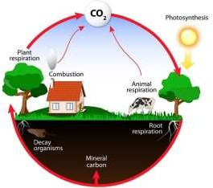

Nitrogen cycle
Nitrogen is an essential component of protein and required by all living organisms including human beings. Our atmosphere contains nearly 79% of nitrogen but it can not be used directly by the majority of living organisms. Broadly like corbondioxide, nitrogen also cycles from gaseous phase to solid phase then back to gaseous phase through the activity of a wide variety of organisms. Cycling of nitrogen is vitally important for all living organisms. There are five main processes which essential for nitrogen cycle are elaborated below
- Nitrogen fixation: This process involves conversion of gaseous nitrogen into Ammonia, a form in which it can be used by plants. Atmospheric nitrogen can be fixed by the following three methods: -
- Atmospheric fixation: Lightening, combustion and volcanic activity help in the fixation of nitrogen.
- Industrial fixation: At high temperature (400ºC) and high pressure (200 atm.), molecular nitrogen is broken into atomic nitrogen which then combines with hydrogen to form ammonia.
- Bacterial fixation: There are two types of bacteria- (i) Symbiotic bacteria e.g. Rhizobium in the root nodules of leguminous plants. (ii) Freeliving or symbiotic e.g. 1. Nostoc 2. Azobacter 3.
Cyanobacteria can combine atmospheric or dissolved nitrogen with hydrogen to form ammonia.
- Nitrification: It is a process by which ammonia is converted into nitrates or nitrites by Nitrosomonas and Nitrococcus bacteria respectively. Another soil bacteria Nitrobacter can covert nitrate into nitrite.
- Assimilation: In this process nitrogen fixed by plants is converted into organic molecules such as proteins, DNA, RNA etc. These molecules make the plant and animal tissue.
- Ammonification: Living organisms produce nitrogenous waste products such as urea and uric acid. These waste products as well as dead remains of organisms are converted back into inorganic ammonia by the bacteria This process is called ammonification. Ammonifying bacteria help in this process.
- Denitrification: Conversion of nitrates back into gaseous nitrogen is called denitrification. Denitrifying bacteria live deep in soil near the water table as they like to live in oxygen free medium. Denitrification is reverse of nitrogen fixation.
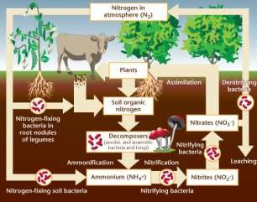

Water Cycle
Water is essential for life. No organism can survive without water. Precipitation (rain, snow, slush dew etc.) is the only source of water on the earth. Water received from the atmosphere on the earth returns back to the atmosphere as water vapour resulting from direct evaporation and through evapotranspiration the continuous movement of water in the biosphere is called water cycle (hydrological cycle). Earth is a watery planet of thesolar system, about 2/3rd of earth surface is covered with water. However a very small fraction of this is available to animals and plants. Water is not evenly distributed throughout the surface of the earth. Almost 95 % of the total water on the earth is chemically bound to rocks and does not cycle. Out of the remaining 5%, nearly 97.3% is in the oceans and 2.1% exists as polar ice caps. Thus only 0.6% is present as fresh water in the form of atmospheric water vapours, ground and soil water. The driving forces for water cycle are 1) solar radiation 2) gravity. Evaporation and precipitation are two main processes involved in water cycle. These two processes alternate with each other Water from oceans, lakes, ponds, rivers and streams evaporates by sun’s heat energy. Plants also transpire huge amounts of water. Water remains in the vapour state in air and forms clouds which drift with wind. Clouds meet with the cold air in the mountainous.
On an average 84% of the water is lost from the surface of the through oceans by evaporation. While 77% is gained by it from precipitation. Water run-off from lands through rivers to oceans makes up 7% which balances the evaporation deficit of the ocean. On land, evaporation is 16% and precipitation is 23%.
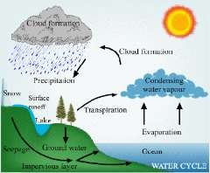

Phosphorus Cycle
Phosphorus is a major constituent of biological membranes, nucleic acids and cellular energy transfer systems. Many animals also need large quantities of this element to make shells, bones and teeth. The natural reservoir of phosphorus is rock, which contains phosphorus in the form of phosphates. When rocks are weathered, minute amounts of these phosphates dissolve in soil solution and are absorbed by the roots of the plants (Fig.). Herbivores and other animals obtain this element from plants. The waste products and the dead organisms are decomposed by phosphate-solubilising bacteria releasing phosphorus. Unlike carbon cycle, there is no respiratory release of phosphorus into atmosphere. The other two major and important differences between carbon and phosphorus cycle are firstly, atmospheric inputs of phosphorus

through rainfall are much smaller than carbon inputs, and, secondly, gaseous exchanges of phosphorus between organism and environment are negligible.

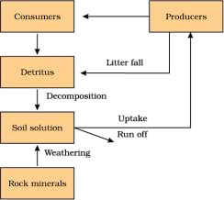

ECOLOGICAL PYRAMIDS
Ecological pyramids are the graphical representations of trophic levels in an ecosystem. The base of each pyramid represents the producers or the first trophic level while the apex represents tertiary or top level consumer. The three ecological pyramids that are usually studied are (a) pyramid of number; (b) pyramid of biomass and (c) pyramid of energy.
Pyramid of number: In this type of ecological pyramid, the number of organisms in each trophic level is considered as a level in the pyramid. The pyramid of numbers is usually upright except for some situations like that of the detritus food chain, where many organisms feed on one dead plant or animal.
- Pyramid of biomass: In this particular type of ecological pyramid, each level takes into account the amount of biomass produced by each trophic level. The pyramid of biomass is also upright except for that observed in oceans where large numbers of zooplanktons depend on a relatively smaller number of phytoplanktons.
- Pyramid of energy: Pyramid of energy is the only type of ecological pyramid, which is always upright as the energy flow in a food chain is always unidirectional. Also, with every increasing trophic level, some energy is lost into the environment.
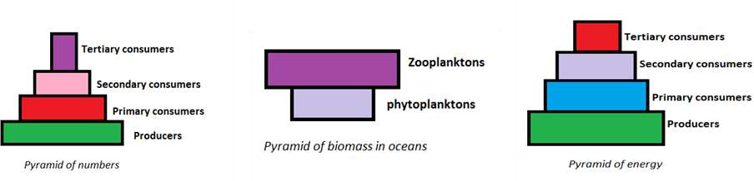

Ecosystem homeostasis :Ecosystem homeostasis is equilibrium, or a balance of the organisms in an ecosystem. This means the populations of species in the ecosystem are relatively stable. Over time, these populations will change, but in the short term, they should move up and down in cycles around an average value.

TYPES OF ECOSYSTEM

An ecosystem consists of all the living and non-living things in a specific natural setting. Plants, animals, insects, microorganisms, rocks, soil, water and sunlight are major components of many ecosystems. All types of ecosystems fall into one of two categories: terrestrial or aquatic. Terrestrial ecosystems are land-based, while aquatic are water-based.The word “biome” may also be used to describe terrestrial ecosystems which extend across a large geographic area, such as tundra.

Terrestrial Ecosystems

The ecosystem which is found only on landforms is known as the terrestrial ecosystem. The main factor which differentiates the terrestrial ecosystems from the aquatic ecosystems is the relative shortage of water in the terrestrial ecosystems and as a result the importance that water attains in these ecosystems due to its limited availability. Another factor is the better availability of light in these ecosystems as the environment is a lot cleaner in land than it is in water. The main types of terrestrial ecosystems are the forest ecosystems, the desert ecosystems, the grassland ecosystems and the mountain ecosystems. We are going to study all of these individually here in detail.

Forest Ecosystems
These ecosystems have an abundance of flora or plants and hence in these ecosystems a large number of organisms live in a small space. This means that these ecosystems have a high density of living organisms. These ecosystems are classified according to their climate type as tropical, temperate or boreal i.e; tropical evergreen forest, tropical deciduous forest, temperate evergreen forest, temperate deciduous forest and taiga. In the tropics, rainforest ecosystems contain more diverse flora and fauna than ecosystems in any other region on earth. In these warm, moisture-laden environments, trees grow tall and foliage is lush and dense, with species inhabiting the forest floor all the way up to the canopy. In temperate zones, forest ecosystems may be deciduous, coniferous or oftentimes a mixture of both, in which some trees shed their leaves each fall, while others remain evergreen year-round. In the far north, just south of the Arctic, boreal forests – also known as taiga – feature abundant coniferous trees.

  - Grassland Ecosystems

The grasslands are the areas which comprise mainly of the grasses with a little number of shrubs
and trees. Grazing animals, insectivores and herbivores are the main types of organisms which
are found in these regions. The three major types of grasslands are the prairies, savannas and

steppes. Grassland ecosystems are typically found in tropical or temperate regions, although they can exist in colder areas as well, as is the case with the well-known Siberian steppe. Grasslands share the common climactic characteristic of semi-aridity. Trees are sparse or non-existent, but flowers may be interspersed with the grasses. Grasslands provide an ideal environment for grazing animals.

Savanna are the tropical grasslands which are dry seasonally and have a large number of predators and grazers. Prairies are temperate grasslands which are totally devoid of large shrubs and trees. Prairies are of three different types, mixed grass, tall grass and short grass prairies.

Desert Ecosystems

The common defining feature among desert ecosystems is low precipitation, generally less than 25 centimeters, or 10 inches, per year. Almost 17% of all the land on this planet is occupied by the desert ecosystems.The fauna and flora in these ecosystems is generally not much developed because of the high temperatures, intense sunlight and low availability of water. The main vegetation of such regions are the shrubs, bushes and a few grasses and trees. The stems and leaves of these plants are also developed in order to conserve as much water as possible. Camels, reptiles and some insects and birds are the living creatures which are found in such regions.
Not all deserts are hot – desert ecosystems can exist from the tropics to the arctic, but regardless of latitude, deserts are often windy. Some deserts contain sand dunes, while others feature mostly rock.

Tundra Ecosystems

As with deserts, a harsh environment characterizes ecosystems in the tundra. In the snow- covered, windswept, treeless tundra, the soil may be frozen year-round, a condition known as permafrost. The mountain ecosystem is the most scattered and diverse in terms of the habitats that it provides. A large number of animals and plants are found in this ecosystem. Though the conditions at the very high altitudes can be very demanding allowing only the survival of the treeless alpine vegetation. Another important feature about these ecosystems is that the animals which live here have thick fur coats for protection against cold and generally have a long hibernation period in the winters. The slopes at lower altitudes are generally covered with coniferous forests.
During the brief spring and summer, snows melt, producing shallow ponds which attract migrating waterfowl. Lichens and small flowers may become visible during this time of year. The term “tundra” most commonly denotes polar areas, but at lower latitudes, tundra-like communities known as alpine tundra may be found at high elevations.

Aquatic Ecosystem
An ecosystem which exists in a body of water is known as an aquatic ecosystem. The communities of living organisms which are dependent on each other and the aquatic surroundings of their environment for their survival exist in the aquatic ecosystems. The aquatic ecosystems are mainly of two types, the freshwater ecosystems and the marine ecosystems.

Marine Ecosystem
Marine ecosystems are the biggest ecosystems. They cover around 71% of earth’s surface and also contain almost around 97% of the total water present on earth. High amounts of minerals and salts are generally present in the water in the marine ecosystems and to better understand the amount and composition of the different minerals and salts in the water in different marine ecosystems. Marine ecosystems differ from freshwater ecosystems in that they contain saltwater, which usually supports different types of species than does freshwater. Marine ecosystems are the most abundant types of ecosystems in the word. They encompass not only the ocean floor and surface but also tidal zones, estuaries, salt marshes and saltwater swamps, mangroves and coral reefs.

Freshwater Ecosystem
The freshwater ecosystems are very small in magnitude as compared to the marine ecosystems as these covers only 0.8% of the earth’s surface and only account for 0.009% of the total water present on earth. There are three basic kinds of freshwater ecosystems and these are Lentic, Lotic, and Wetlands. The lentic ecosystems are slow-moving or still water like ponds or lakes. Lotic ecosystems are fast-moving water like rivers. The wetlands are those systems where soil remains saturated for a long period of time. Many different species of reptiles, amphibians, and around 41% of the world’s fish species live in these ecosystems. The faster moving waters contain more dissolved oxygen than the slow moving waters and hence support greater biodiversity.
Pond Ecosystems – These are usually relatively small and contained. Most of the time they include various types of plants, amphibians and insects. Sometimes they include fish, but as these cannot move around as easily as amphibians and insects, it is less likely, and most of the time fish are artificially introduced to these environments by humans.
River Ecosystems – Because rivers always link to the sea, they are more likely to contain fish alongside the usual plants, amphibians and insects.
These sorts of ecosystems can also include birds because birds often hunt in and around water for small fish or insects.
As is clear from the title, freshwater ecosystems are those that are contained to freshwater environments. This includes, but is not limited to, ponds, rivers and other waterways that are not the sea (which is, of course, saltwater and cannot support freshwater creatures for very long). Freshwater ecosystems are actually the smallest of the three major classes of ecosystems, accounting for just 1.8% of the total of the Earth’s surface. The ecosystems of freshwater systems include relatively small fish (bigger fish are usually found in the sea), amphibians (such as frogs, toads and newts), insects of various sorts and, of course, plants. The absolutely smallest living part of the food web of these sorts of ecosystems is plankton, a small organism that is often eaten by fish and other small creatures.

ECOSYSTEM SERVICES
Ecosystem services are the benefits that people obtain from ecosystems. They support, directly or indirectly, our survival and quality of life. Some ecosystem services are well known, such as those which are essential for life (e.g. food and clean air and water) or those which improve our quality of life (e.g. recreation and beautiful landscapes). Other services are often taken for granted, such as natural processes (e.g. pollination and flood regulation) (Fig 2). According to the Millennium Ecosystem Assessment (MA) that 60% of ecosystem services are being degraded or used unsustainably, often resulting in significant harm to human well-being. The MA categorised ecosystem services into four classes:
- Provisioning services, which are the products obtained from ecosystems, such as food, water, fuel and materials for building. Agro-ecosystems provide food for human consumption and, together with the associated ecosystems supporting marine and freshwater fisheries, underpin global food security. Ecosystems play important roles in the global hydrological cycle, contributing to water provision, regulation and purification (Dudley and Stolton 2003; Bruijnzeel 2004; Brauman et al. 2007). The provision of fuels and fibres, medicinal and other biochemical resources such as metabolites, pharma-ceuticals, nutrients, crop protection chemicals, cosmetics and other natural products for industrial use and as a basis for biomimetics that may become increasingly important in nanotechnology applications (Ninan 2009). Biodiversity has also played an iconic, ornamental role throughout the development of human society. Uses of plant and animal parts, especially plumage of birds, have been important in conferring individual status, position and influence. Ornamental plants are typically grown for the display of their flowers but other common ornamental features include leaves, scent, fruit, stem and bark.
- Regulating services, Ecosystems contribute to several of natural processes, like air quality regulation, climate regulation, water/flood regulation, disease and pest control, pollination and water purification, environmental regulation services of importance for human wellbeing, particularly in urban areas where vegetation reduce air and noise pollution, mitigate the “urban heat island effect” (Santomouris, 2001), and reduce impacts related to climate change (Bolund and Hunhammar, 1999). Numerous factors interact in the regulation of climate, including the reflection of solar radiation by clouds, dust and aerosols in the atmosphere. Vegetation cover also play a key factor in preventing soil erosion and vegetation cover combined with drought resulted in unprecedented wind erosion, destroying farmland and livelihoods.
- Cultural services, which are the non-material benefits people, obtain from ecosystems and landscapes through spiritual enrichment, recreation and aesthetic enjoyment.
- Supporting services, such as soil formation, photosynthesis and nutrient and water cycling which are necessary for the production of all other ecosystem services. In some estimates, over 75% of the world's crop plants, as well as many plants that are source species for pharmaceutical s , rely on pollination by animal vectors (Nabhan and Buchman, 1997). Klein et al. (2007) found that, for 87 out of 115 leading global crops (representing up to 35% of the global food supply), fruit or seed numbers or quality were increased through animal pollination. In many agricultural systems, pollination is actively managed through the establishment of populations of domesticated pollinators, particularly the honeybee.

Ecosystem preservation and conservation strategies
It has taken millions of years of evolution, to accumulate this rich diversity in nature, but we could lose all that wealth in less than two centuries if the present rates of species losses continue. Ecosystem and its conservation are now vital environmental issues of international concern as more and more people around the world begin to realise the critical importance of biodiversity for our survival and well- being on this planet. Ecosystem is a wealth to which no value can be put. In the final analysis, the very survival of the human race is dependent on conservation of ecosytem. It is evident that this invaluable heritage is being destroyed at an alarming rate due to several reasons. There are several strategies which are adapted for conservation of ecosytem. Some of these are
- Legislation Formal policies and programmes for conservation and sustainable utilisation of ecosytem resources date back to several decades. The concept of environmental protection is enshrined in the Indian constitution in Articles 48a and 51a (g). Major central acts relevant to biodiversity include: Environment Protection Act, 1986; Fisheries Act, 1897; Forest Act, 1927; Forest (Conservation) Act, 1980; Wildlife (Protection) Act 1972 and Wildlife (Protection) Amendment Act 1991. Biological Diversity Act, 2002.
- In -situ Conservation Conserving the animals and plants in their natural habitats is known as in situ conservation. The established natural habitats are: National parks and sanctuaries; Biosphere reserves; Nature reserves; Reserved and protected forests; Preservation plots ; Reserved forests. Biosphere Reserves are another category of protected areas. Under this, a large area is declared as a Biosphere Reserve where wildlife is protected, but local communities are allowed to continue to live and pursue traditional activities within the Reserve. A programme “Eco-development” for insitu conservation of biological diversity involving local communities was initiated. It integrates the ecological and economic parameters for sustained conservation of ecosystems by involving local communities with maintenance of earmarked regions surrounding protected areas.
- Ex-situ Conservation Ex-situ conservation of plants and animals preserve/ or protect them away from their natural habitat. This could be in zoological parks and botanical gardens or through the forestry institutions and agricultural research centres. A lot of effort is under way to collect and preserve the genetic material of crops, animal, bird and fish species.
- Community Participation in Biodiversity Conservation It is being recognized that no legal provisions can be effective unless local communities are involved in planning, management and monitoring conservation programmes. Successful conservation strategies will have to have the confidence and participation of the local communities.
- Recording Indigenous Knowledge The lives of local communities are closely interwoven with their environment, and are dependent upon their immediate resources for meeting their needs. These communities have a vast knowledge about local flora and fauna which is very important for biodiversity conservation. Much of this knowledge is orally passed on from generation to generation.

- International Conservation Strategies Conserving biodiversity is not an issue confined to any one country or community. It is a crucial global concern. Several international treaties and agreements are in place in the attempt to strengthen international participation and commitment towards conserving biodiversity. Some of these are:
  - The Convention on Biological Diversity: This was signed during the Earth Summit in 1992. It focuses not only on conserving biodiversity but also on sustainable use of biological resources and equitable sharing of benefits arising from its use.
  - The Convention on International Trade in Endangered Species of Wild Flora and Fauna (CITES): This is an international treaty which is designed to protect wild plants and animals affected by international trade. The treaty, in force since 1975, controls the export, import and re-export of endangered and threatened wildlife.
  - The Convention on Wetlands of International Importance: This Convention, also known as the Ramsar Convention, was signed in Ramsar (Iran) in 1971 and came into force in December 1975. It provides a framework for international cooperation for the conservation of wetland habitats which have been designated to the ‘List of Wetlands of International Importance’ (Dilip Sarkar, Conserving Biodiversity in India).

ECOSYSTEM RESTORATION
Ecological restoration is the process of reclaiming habitat and ecosystem functions by restoring the lands and waters on which plants and animals depend.
Ecological restoration seeks to initiate or accelerate ecosystem recovery following damage, degradation, or destruction. It is a corrective step that involves eliminating or modifying causes of ecological degradation and re-establishing the natural processes — like natural fires, floods, or predator-prey relationships — that sustain and renew ecosystems over time.
Restoration practitioners do not carry out the actual work of ecosystem recovery. Rather, they create the conditions needed for recovery so the plants, animals, and microorganisms can carry out the work of recovery themselves. Assisting recovery can be as simple as removing an invasive species or reintroducing a lost species or a lost function (like fire); or as complex as altering landforms, planting vegetation, changing the hydrology, and reintroducing wildlife.

The goal of ecological restoration is to return a degraded ecosystem to its historic trajectory, not its historic condition. The ecosystem may not necessarily recover to its former state since contemporary ecological realities, including global climate change, may cause it to develop along an altered trajectory, just as these same realities may have changed the trajectory of nearby undisturbed ecosystems. History plays an important role in restoration, but contemporary conditions must also be taken into consideration.

